**Capstone Project:**

**Analytical CRM Development for a Bank**

**Introduction:**

This comprehensive project aims to analyze customer data provided by a bank to understand customer churn (customer loss). We'll identify key factors driving churn, develop actionable insights to improve customer retention, and ultimately enhance customer satisfaction. By leveraging various tools like Excel, Power BI, and SQL, we'll gain a deeper understanding of customer behavior and preferences.

**Objective:**

The primary objective of this project is to reduce customer churn and enhance customer satisfaction for the bank. This will be achieved through:

1. Identifying key factors contributing to customer churn.

2. Developing insights to improve customer retention strategies.

3. Enhancing service delivery based on customer preferences and behavior.

**Introduction to Data**

The bank has provided several datasets related to customers, including:

* CustomerId**:** A unique identifier for each customer.
* CreditScore**:** A numerical representation of the customer's creditworthiness.
  + **Credit score:** 
    - Excellent: 800–850
    - Very Good: 740–799
    - Good: 670–739
    - Fair: 580–669
    - Poor: 300–579
* GeographyID**:** A numerical identifier that likely corresponds to a geographical location, such as a country or region.
* GenderID**:** A numerical identifier for the customer's gender, where for example, '1' could represent male and '2' could represent female.
* Age**:** The age of the customer.
* Tenure**:** The number of years the customer has been with the bank.
* Balance**:** Current balance in the customer's account.
* NumOfProducts: refers to the number of products that a customer has purchased through the bank.
* HasCrCard: denotes whether or not a customer has a credit card. This column is also relevant, since people with a credit card are less likely to leave the bank.
  + - 1 represents credit card holder
    - 0 represents non credit card holder

* **IsActiveMember:** active customers are less likely to leave the bank (as per the criteria defined by the bank for identifying the activeness).
  + - 1 represents Active Member
    - 0 represents Inactive Member
* **EstimatedSalary:** as with balance, people with lower salaries are more likely to leave the bank compared to those with higher salaries.
* **Exited:** whether or not the customer left the bank.
  + - 0 represents Retain
    - 1 represents Exit
* **Bank DOJ:** date when the Customer associated/joined with the bank.

**Data Preprocessing**

**1. Data Cleaning in Excel/Power BI:**

* **We have been provided with seven excel file. Having two main files named Bank_churn and customer_info. With the help of VLOOKUP and XLOOKUP I added an extra row in both tables to mention the category name based on category_id like 0 & 1.**
* **Then converted the datatype of the Bank_DOJ into text by using formula =TEXT(cell_value,”yyyy-mm-dd”).**
* **In addition I took the year column for better clarity with formula =LEFT(cell_value,4).**

**2. Data Transformation in SQL:**

* **To add the excel file in the MySQL, I first converted my both excel file into .csv format.**
* **After that I made a database named “sqlproject”.**



* **After creating the database and refreshing, after right clicking on the table, I imported data into MySQL.**

**Creating Columns with DAX (Power BI)**

DAX (Data Analysis Expressions) is a powerful formula language used in Power BI to create calculated columns and measures. Here are some potential DAX column examples:

**Calculated Measures**

Measures are dynamic calculations created within Power BI to summarize data. Here are the explanations for the provided measures:

* **ChurnRate:** This measure calculates the customer churn rate as a percentage. It divides the number of lost customers (LostCustomers) by the total number of customers (TotalCustomers) and multiplies the result by 100 to express it as a percentage.  
  
* **LostCustomers:** This measure simply counts the number of customers who exited the bank (Exited = 1) within the Bank_Churn table using the CALCULATE function and the COUNTROWS function.  
  
* **TotalCustomers:** This measure counts the total number of customers present in the CustomerInfo table using the CALCULATE function and the COUNTROWS function.  
  

**Calculated Columns**

Calculated columns extend your data's capabilities by creating new data points derived from existing information. They offer valuable insights and simplify data exploration. Here's a breakdown of the available calculated columns:

* **AgeBrackets (CustomerInfo table):** This column segments customers into age groups using a nested IF statement:



* **BalanceSegments (Bank_Churn table):** This column segments customers into three categories based on their account balance:



* **CreditScoreSegments (Bank_Churn table):** This new column segments customers by their credit score using a nested IF statement:

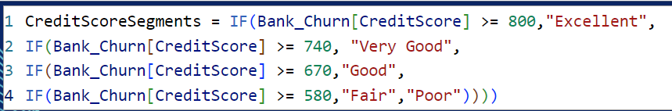

* **CustomerSegments (CustomerInfo table):** This column segments customers based on their estimated salary using a nested IF statement:

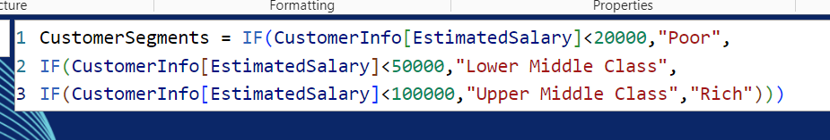

* **Status (CustomerInfo table):** This column classifies customers as "New Customer" or "Old Customer" based on their bank joining year (BankDOJ) using an IF statement and the YEAR function. The specific year defining a "New Customer" can be adjusted.  
  
* **SalarySegments (CustomerInfo table):** This column segments customers based on their estimated salary using a nested IF statement:

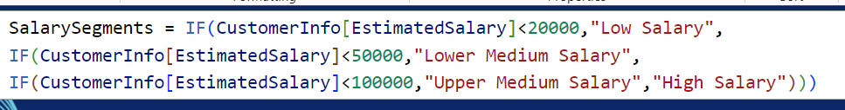

**Explanation of Objective Questions**

**1. Account Balance Distribution by Region: From the below given graph, it can be seen that France shows maximum sum of balance of about 0.31bn while Spain just show half of that of France that is 0.15bn.  
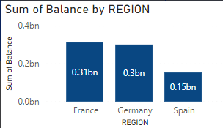**

**2. Top 5 Highest Estimated Salary Earners (Last Quarter)(SQL):**

This SQL query identifies the top 5 customers with the highest estimated salary who joined the bank in the last quarter (quarter 4) of the year.

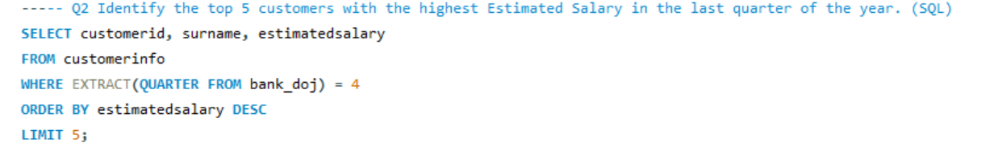

Result:

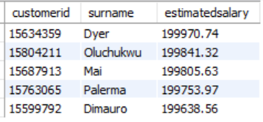

**3. Average Number of Products for Customers with Credit Cards(SQL):**

This SQL query identifies Average Number of Products for Customers with Credit Cards

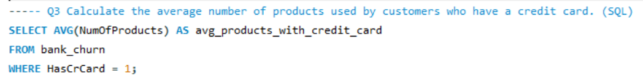

Result:

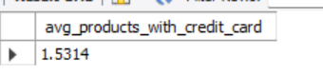

**4. Churn Rate by Gender**This analysis examines customer churn rate segmented by gender (male/female) for the most recent year (using a Bank DOJ slicer).

(ChurnRate = DIVIDE([LostCustomers],[TotalCustomers])*100) determines the churn rate.

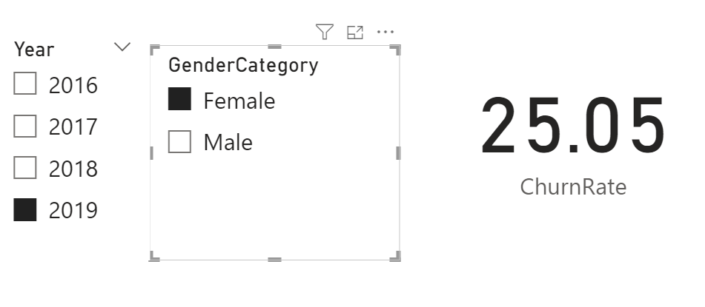 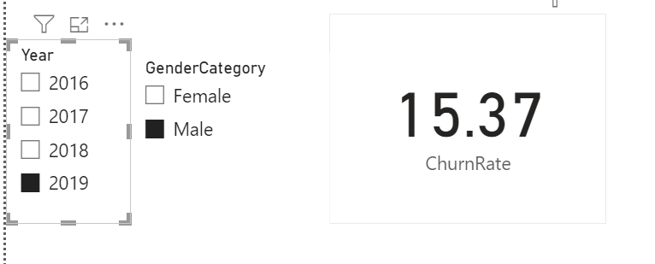

**5. Average Credit Score of Exited vs. Retained Customers(SQL)**

This SQL query identifiesAverage Credit Score of Exited vs. Retained Customers.

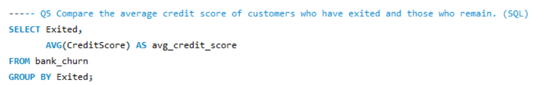

Result:

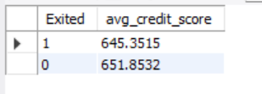

**6. Gender with Higher Average Salary and its Relation to Active Accounts:**

This SQL query identifiesGender with Higher Average Salary and its Relation to Active Accounts:

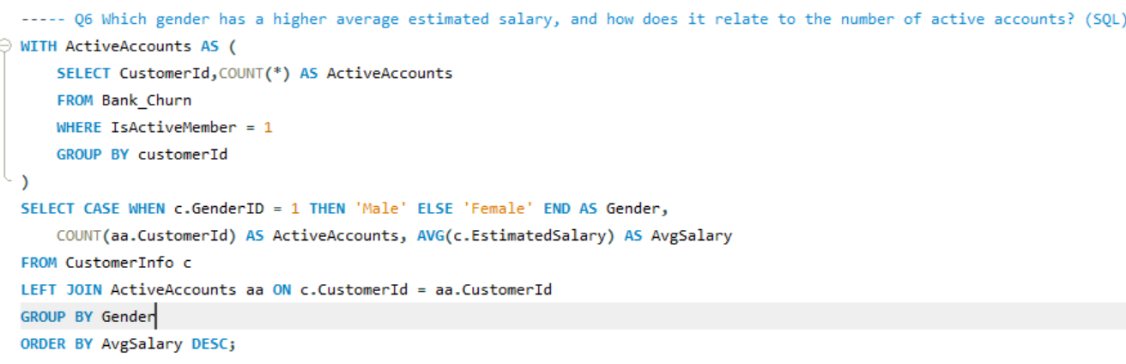

Result:

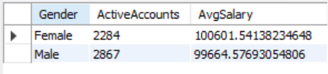

**7. Customer Segment with Highest Exit Rate**This query utilizes a Common Table Expression (CTE) named credit_score_segments to categorize customers based on their credit score:

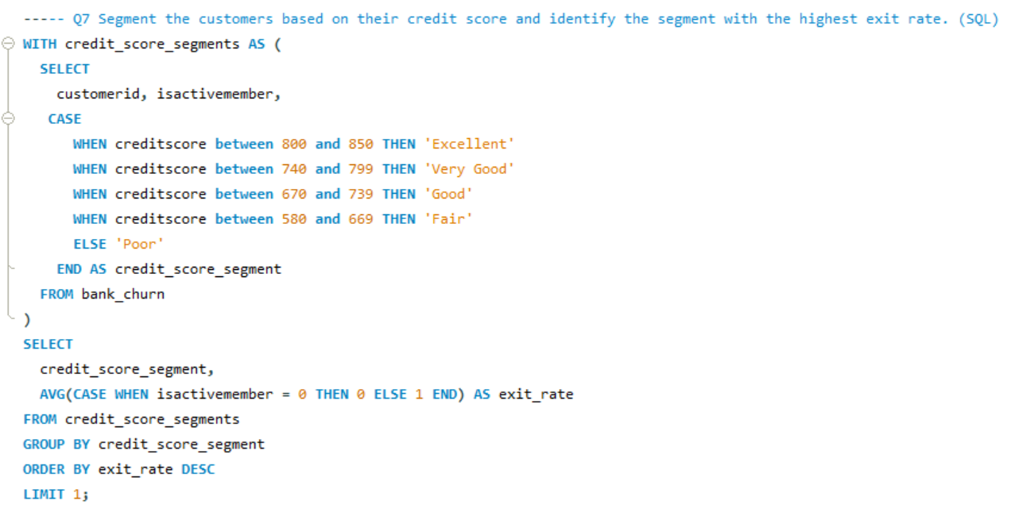

Result:

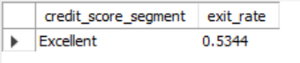

**8. Geographic Region with Most Active Customers (Tenure > 5 Years):**

This SQL query identifies Geographic Region with Most Active Customers (Tenure > 5 Years):

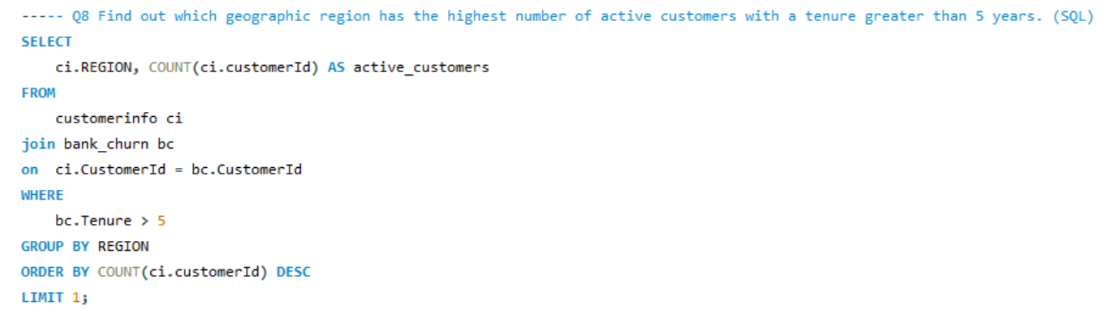

Result:

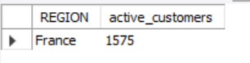

**9. Impact of Credit Card on Customer Churn**

The chart reveals a potentially higher churn rate for customers with credit cards (HasCrCard = 1) compared to those without credit cards.

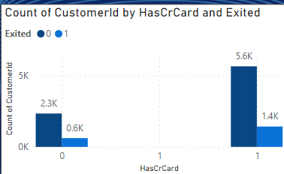

**10. Most Common Number of Products for Exited Customers:** From the below given graph it can be seen that product 1 (1.4k) was the mostly commonly used product by exited customers. Which is found out by applying filter to it. While product 4 (0.1k) was least used product by the exited customers.

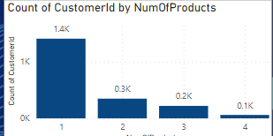

**11. Trend of Customer Joining Over Time (Yearly/Monthly Seasonality)**

The customer joining trend appears to be increasing over time. This indicates a positive growth in customer acquisition.There might be seasonal patterns present in the data. It seems that customer joins could potentially peak around the end of the year (December) but due to the limited data points, it's difficult to confirm a strong seasonal trend.

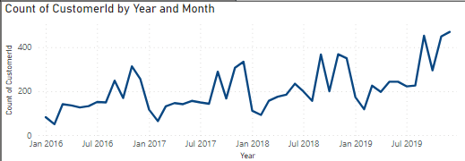

**12. Relationship Between Number of Products and Balance for Exited Customers**The most common number of products used by exiting customers is 1. This suggests that a significant portion of customers who churned had only used a single product. There’s a general downward trend as the number of products used increases. This suggests that customers who churned tend to have fewer products compared to active customers. Its been provided by filtering out the exited customers.

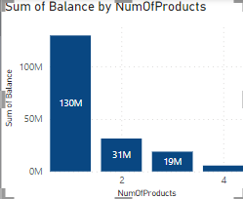

**13. Outliers in Balance Among Retained Customers.**We are identifying potential outliers in terms of account balance among customers who have remained active with the bank (not churned). Here's a breakdown of the method and some insights:Finding Outliers for Active Customers:

* Column chart likely shows the distribution of account balances for active customers.
* Since the minimum balance is zero and there are no negative values, we only need to consider outliers on the higher end (above the upper threshold (i.e., 201274.46)).
* There were 15 potential outliers.  
    
  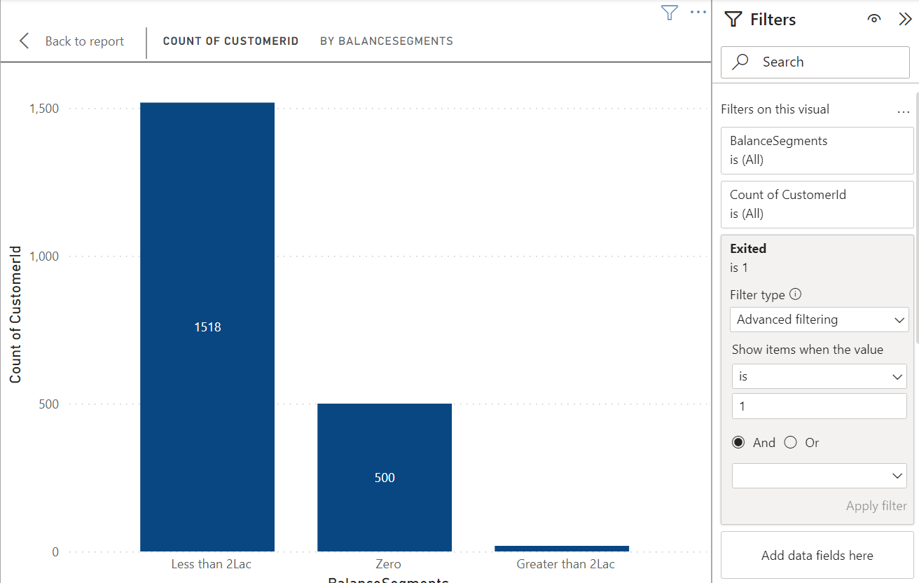  
   **14. Number of Tables and Categorical Variable Tables.**We had Seven Different tables i.e., ActiveCustomer, Bank_Churn,CreditCard,CustomerInfo,ExitCustomer,Gender,Geography. Which I made it to two main tables.Tables with Categorical Variables:
* ExitCustomer: Contains categorical variables like Exit Category(Exit ,Retain).
* Gender: Contains categorical variables like Gender Category (Male,Female).
* Geography:Contains categorical variables like Geography Location (France, Spain,Germany).
* ActiveCustomer: Contains categorical variables like Active Category (Active Member , Inactive Member).
* CreditCard: Contains categorical variables like Category (Credit-card holder , Non-Credit card holder)

**15. Gender-wise Average Income and Ranking by Geography**

This SQL code calculates the average income (estimated salary) for males and females within each geographic location and assigns a rank based on the average salary.

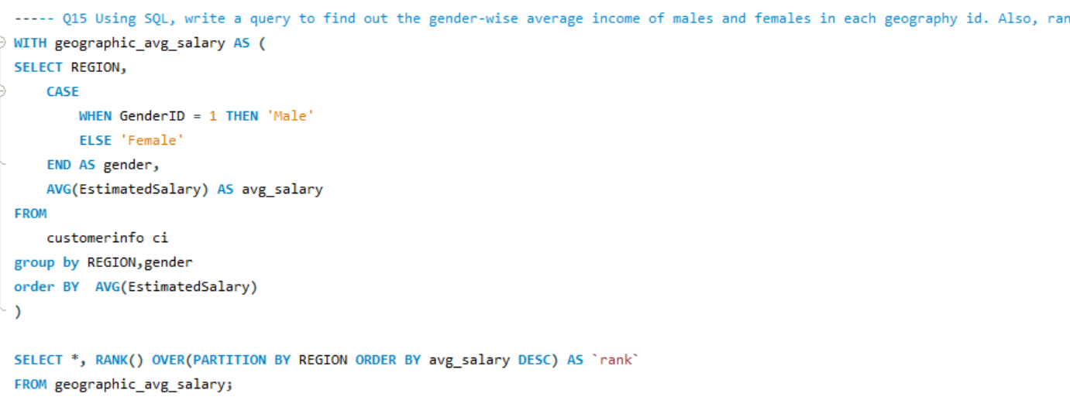

Result:

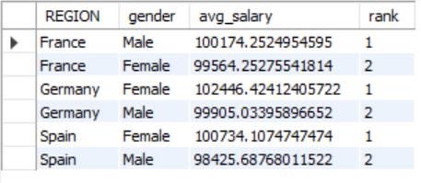

**16. Average Tenure of Exited Customers by Age Bracket.**This SQL query calculates the average tenure (time with the bank)   
of exited customers (Exited = 1) categorized into age brackets (18-30, 31-50, 50+) to understand churn patterns across different age groups.

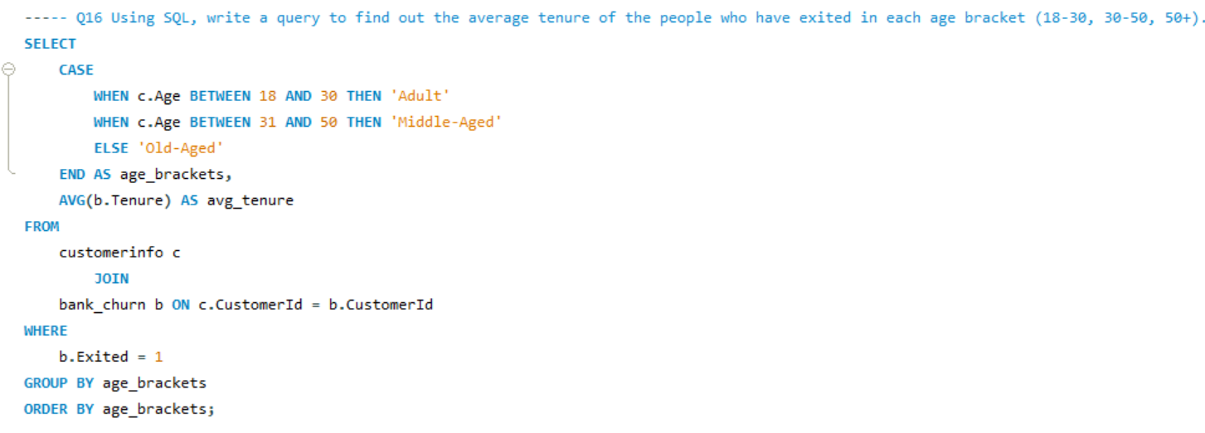

Result:

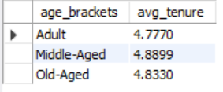

**17. Correlation Between Salary and Balance (Overall and by Exit Status)** There is no such correlation found.

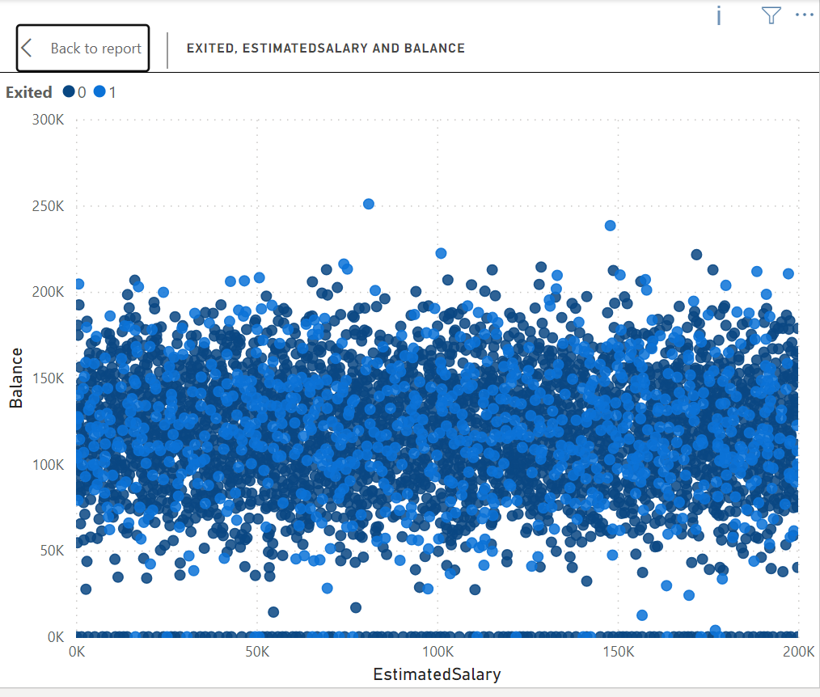

**18. Correlation Between Salary and Credit Score**There is no such correlation found. Credit score is not the alone function of salary(credit score alone can’t be determined by salary).  
 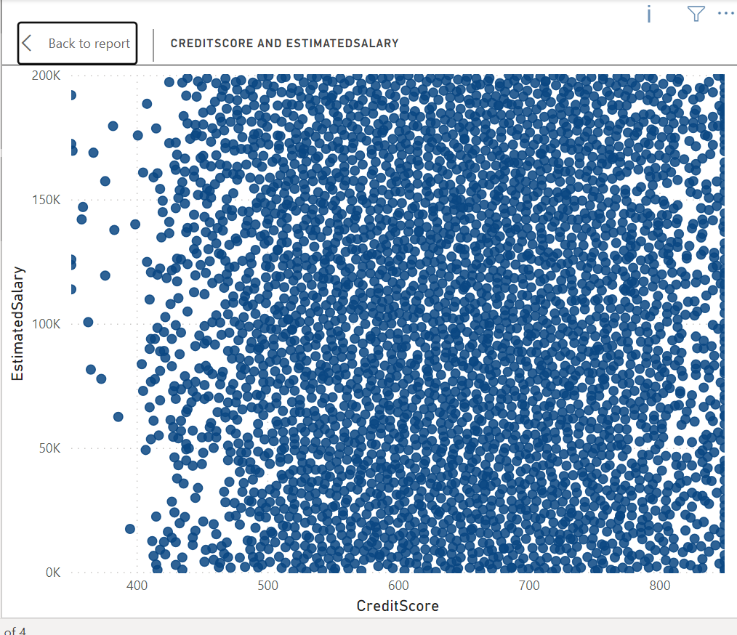

**19. Ranking Credit Score Buckets by Customer Churn**The chart reveals the churn rate (percentage of customers who exited) for each credit score segment. The segment with the highest bar i.e. Fair likely represents the credit score group with the most churned customers.  
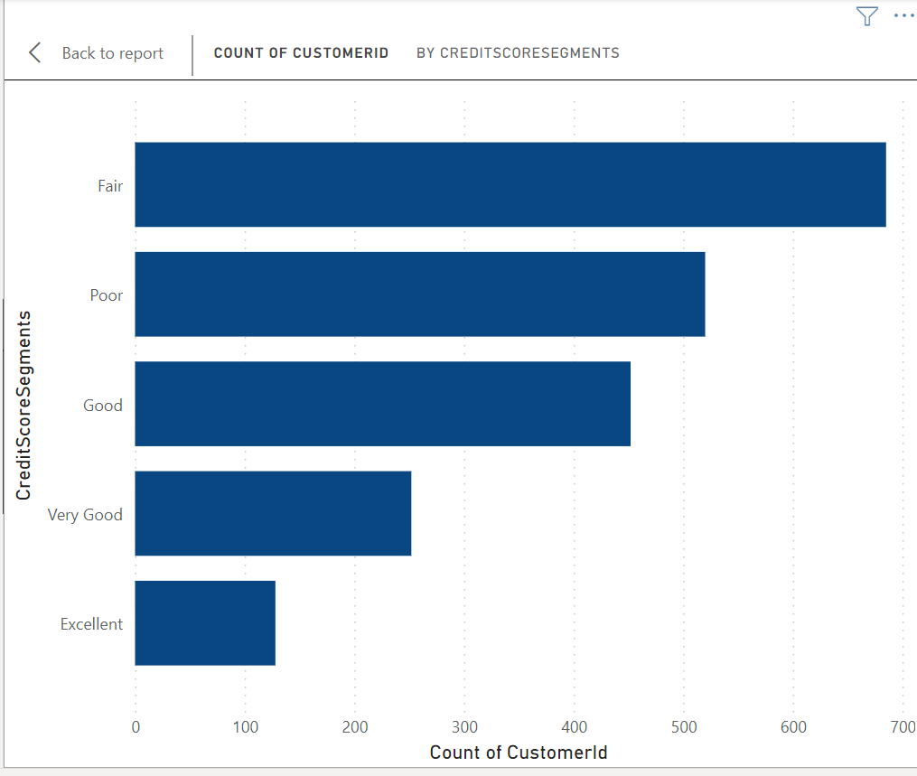

**20. Number of Customers with Credit Card by Age Bucket (Identify Buckets Below**

This SQL code explores the relationship between customer age groups ("age_brackets") and credit card ownership. This query helps identify age groups with a lower than average credit card ownership rate. By analyzing these segments, you can gain insights into customer behavior and potentially develop targeted marketing campaigns to promote credit card adoption within these age groups.  
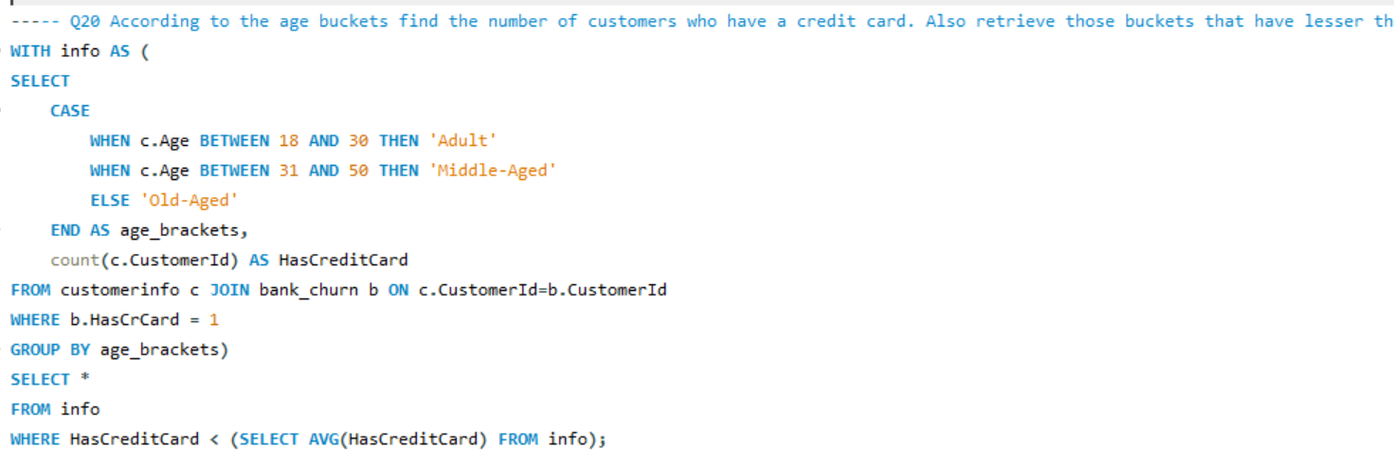

Result:

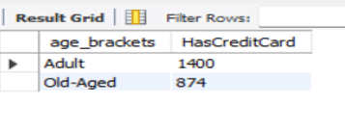

**21. Ranking Locations by Churn and Average Balance**This code identifies locations with the most churned customers (who exited the bank).

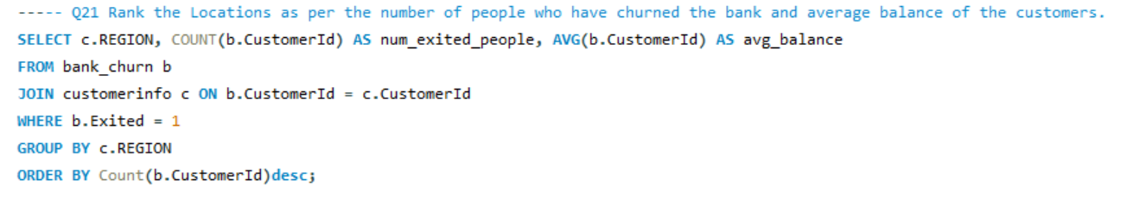

Result:

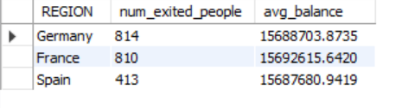

**22. Combining CustomerID and Surname in a New Column.**Here's an explanation of how to create a new column named "CustomerID_Surname" in the result set of a join between the "CustomerInfo" table and another table where the primary key is a combination of CustomerID and Surname:

1. Data Types:

* Ensure the CustomerID in "CustomerInfo" is a character data type or can be converted to one. The CONVERT function might not be necessary depending on the database system.

2. Join on Individual Columns:

* Perform a join on the "CustomerInfo" table and the other table using separate columns for CustomerID and Surname instead of a combined primary key.

3. Create New Column:

* Within the SELECT clause of your query, use the CONCAT function (or similar function depending on the database system) to concatenate the CustomerID and Surname columns from "CustomerInfo" with a delimiter (underscore "_" in this case).

**23. Retrieving Exit Category Without Joins.**This code retrieves customer data from the Bank_Churn table and adds a new column named "ExitCategory" to classify customers as 'Retain' (not churned) or 'Exit' (churned) based on the value in the Exited column (likely 0 for non-churned, non-zero for churned).

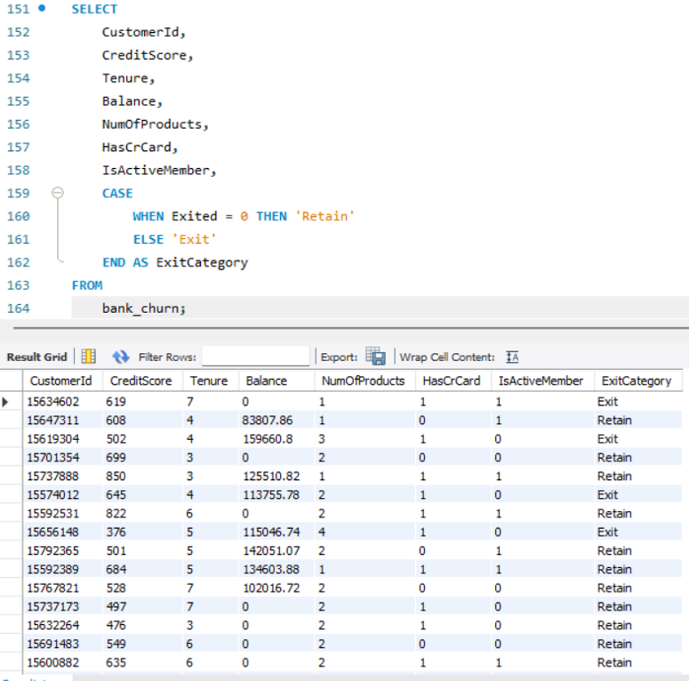

**24. Handling Missing Values**

This section addresses missing values, which can occur when data points are not recorded or unavailable. In our analysis, we're fortunate to have a dataset free of missing values. This eliminates the need for imputation techniques that might introduce assumptions or biases.

General Approaches to Missing Values (for future reference):

While our dataset is free of missing values, it's valuable to be aware of common approaches for handling them in future analyses:

* Deletion: This involves removing rows or columns with missing values. This can be appropriate if the missing data is minimal and doesn't significantly impact the analysis. However, it can also lead to a loss of information.
* Imputation: This replaces missing values with estimated values. Techniques include mean/median/mode imputation, k-Nearest Neighbors (KNN), or more sophisticated methods. The chosen method should be based on the data type and distribution.
* Modeling Techniques: Some statistical models can handle missing values directly. However, understanding the reasons for missingness is still important.

**25. Retrieving Customer IDs, Last Name, and Status for Surnames Ending in "on"**This SQL query identifies customers with surnames ending in "on" (case-sensitive). It retrieves the following information for these customers:

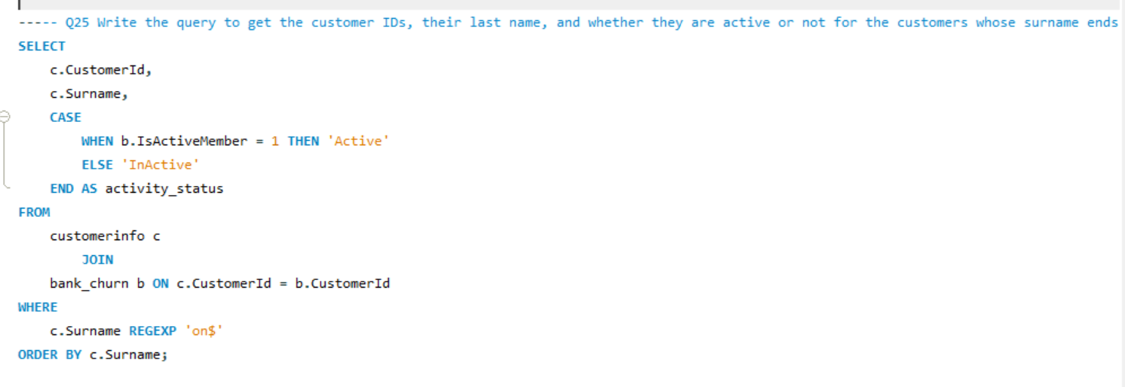

Result:

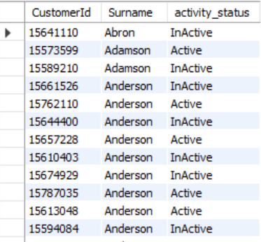

**Exploration Of Subjective Question**

**1. Customer Behavior Analysis.**

This analysis examines the spending patterns of new and long-term customers to understand customer loyalty. We have created three charts to identify trends in average balance, salary, and number of products held by both customer groups.

Let's delve into the key insights revealed by the first chart focusing on average balance.  
 Based on the graph, the average balance of new customers seems to be consistently lower than that of long-term customers. This suggests that long-term customers tend to spend more money with the bank over time.

Here’s a more detailed analysis of the graph:

* The y-axis shows the average balance.
* The x-axis shows the month.
* The blue line represents new customers and the orange line represents long-term customers.
  + There is no consistent pattern for new customers. Their average balance fluctuates throughout the year.
  + Long-term customers, on the other hand, generally show an increasing average balance over time. Their average balance starts lower than new customers in January, but surpasses it by March and continues to climb throughout the year.

However, the overall trend suggests that customers tend to spend more money with the bank the longer they are customers. This could be for a number of reasons, such as:

* Long-term customers may have become more familiar with the bank’s products and services and found more products to use.
* Long-term customers may have increased their income over time, allowing them to save more money.
* The bank may offer better interest rates or other benefits to long-term customers, which could incentivize them to save more money with the bank.

Understanding these customer spending habits can help the bank develop targeted marketing campaigns to attract new customers and retain existing ones.  
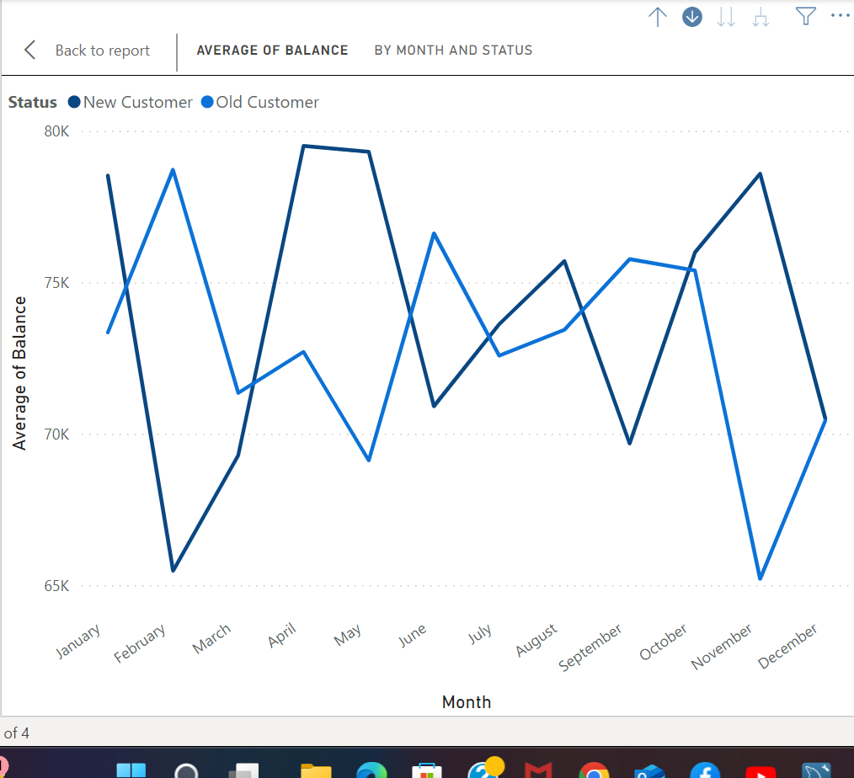

The second chart shows the average salary by month and customer status (new vs. old customers). Here are some key insights from this chart:

* Generally higher salaries for long-term customers: The average salary for long-term customers (orange line) appears to be consistently higher than that of new customers (blue line) throughout the year. This could be due to several factors, such as long-term customers receiving salary increases over time, or new customers starting out in their careers with lower salaries.
* Possible salary increases for new customers: While the average salary starts lower for new customers, there seems to be a slight upward trend throughout the year. This could suggest that new customers are getting raises or finding higher-paying jobs as time goes on.

Overall, this chart suggests a correlation between customer status and salary. Long-term customers tend to have higher average salaries, and new customers may experience salary increases over time.  
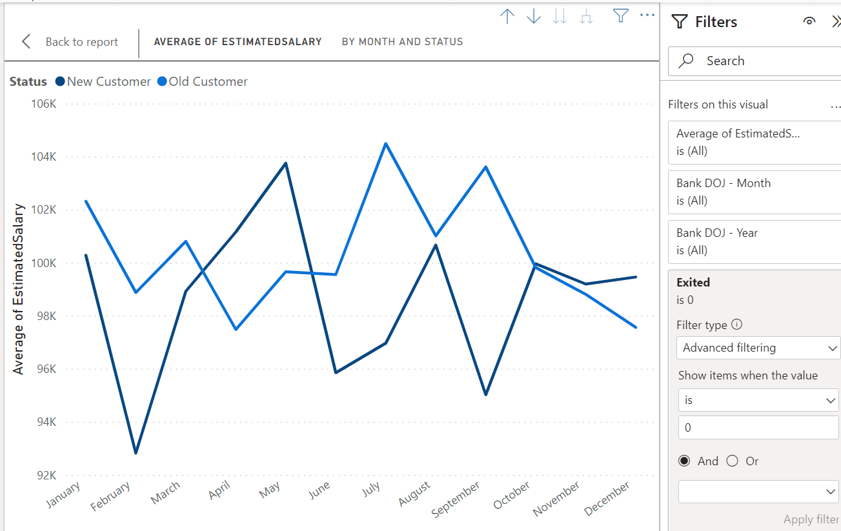  
The third chart shows the average number of products held by new and long-term customers over the course of a year. Here are some key insights:

* Long-term customers tend to hold more products**:** The average number of products held by long-term customers (orange line) is consistently higher than that of new customers (blue line) throughout the year. This suggests that customers tend to acquire more products and services from the bank the longer they are a customer.
* Potential for growth with new customers**:** There appears to be a gradual increase in the average number of products held by new customers (blue line) over time. This suggests that new customers may be adding more products to their accounts as they become more familiar with the bank's offerings.
* New customers start with fewer products**:** In January, new customers hold significantly fewer products compared to long-term customers. This could be because new customers are still in the process of opening accounts and exploring the bank's products and services.

Overall, this chart provides evidence that customer loyalty is associated with an increase in the number of products held.   
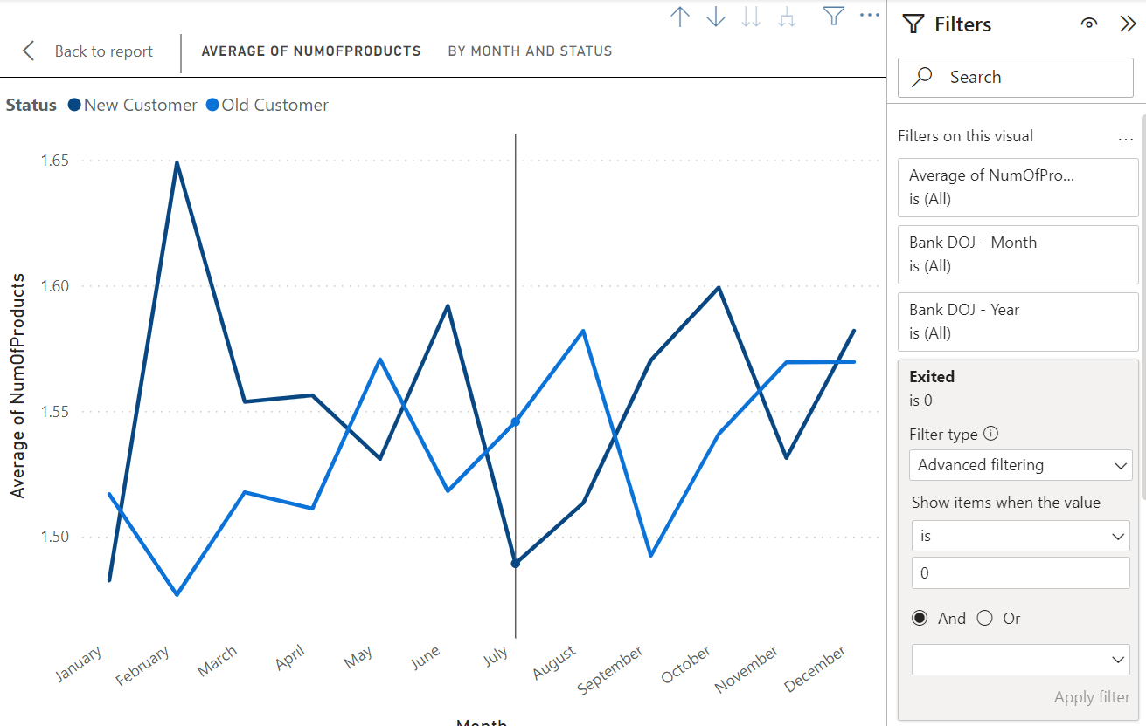

**2. Product Affinity Study:**Customers often use specific bank products together. Analyzing these pairings helps develop targeted cross-selling strategies to increase customer satisfaction and revenue.

Commonly Used Products (Examples):

* Checking Accounts: Core for everyday transactions.
* Debit Cards: Linked to checking, providing convenient access to funds.
* Savings Accounts: Grow savings and often earn interest.
* Credit Cards: Offer a line of credit for purchases, requiring repayment with interest.
* Loans: Tailored financial solutions like mortgages or auto loans.

Cross-Selling Strategies:

* Recommend complementary products: Checking account users might benefit from a debit card and online banking for easy management. Savings account holders could be recommended automatic transfers to boost saving habits or higher-interest options like CDs for larger balances.
* Personalize based on usage: Credit card users with travel habits could benefit from travel rewards cards. Loan seekers might be interested in bundled insurance options.
* Leverage digital platforms: Promote paperless statements and bill autopay through online/mobile banking. Offer investment options or financial tools accessible through these platforms.

By understanding product usage patterns and tailoring recommendations, banks can create a win-win situation: increased revenue and customers who feel their financial needs are being met.

**3. Geographic Market Trends.**This section explores how economic indicators vary across geographic regions and their potential correlation with customer churn rates. We'll analyze three key economic indicators: average balance, average salary, and credit score.

The first chart examines the average balance by region.  
 The chart shows average balance by region, with Germany having the highest. While it doesn't directly address churn, lower balance regions might have higher churn if customers there are more cost-sensitive.  
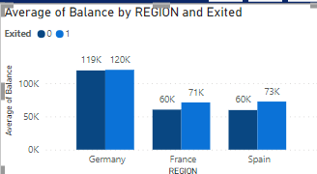  
  
 The second chart you sent shows the average credit score by region.  
The credit score chart shows variations by region, with Germany having the highest average. This, along with churn rate data, could help identify a link between higher credit scores and lower churn (customers are more creditworthy and less likely to switch).

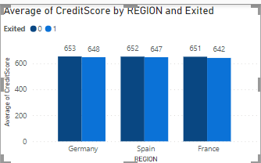  
  
 The third chart shows the average salary by geographical location.   
Similar to the credit score chart, average salary varies by location (Germany highest). This, along with churn data .  
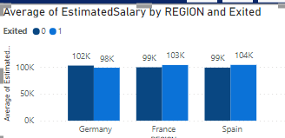

**4. Risk Management Assessment.**Based on the chart, the demographic segments with the most customers are those with lower credit scores ("Lower Middle Class" and "Poor"). These same segments also represent the largest portion of the bank's customers. Therefore, based on the data presented in the chart, we can say that the demographic segments with the most customers are also the ones that pose the highest potential financial risk to the bank.

There are other factors to consider when assessing customer risk besides creditworthiness, such as income and employment history. However, creditworthiness is a strong indicator of a customer's ability to repay loans. Customers with lower credit scores are statistically more likely to default on loans than customers with high credit scores. This means that the bank is more likely to lose money on loans made to customers in the "Lower Middle Class" and "Poor" segments than on loans made to customers in other segments.  
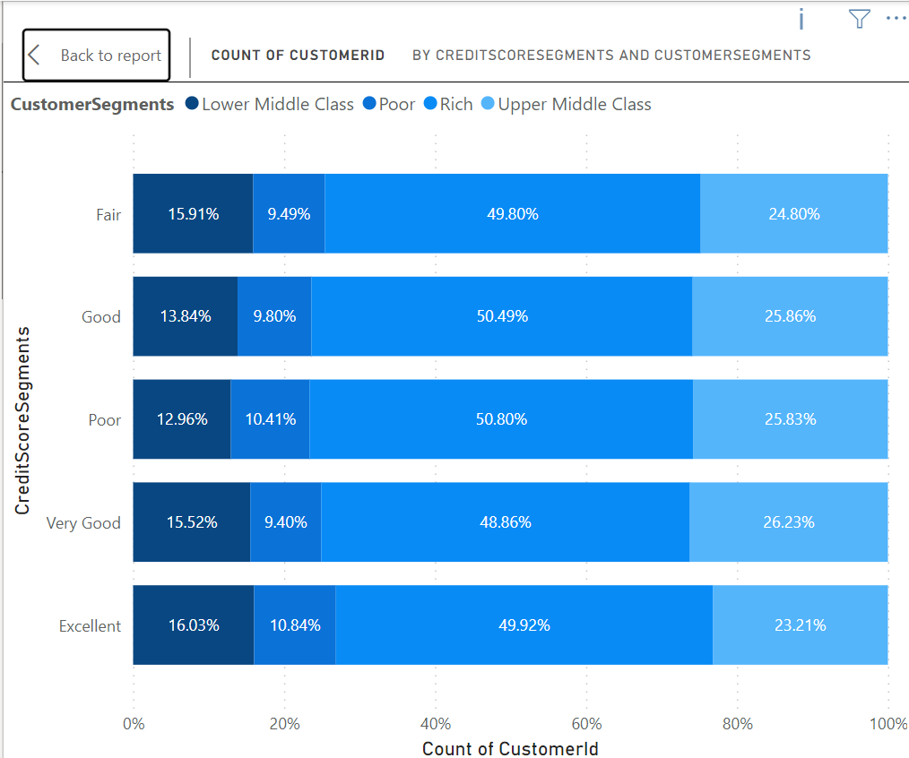

**5. Customer Tenure Value Forecast.**The chart you provided shows the average tenure by balance segments, salary segments, and customer segments. Here are some key insights and predictions you can make based on the data:

* Balance Segments: Customers with higher average balance segments tend to have a longer tenure with the bank. This could be because they are more invested in the bank's products and services, or because the bank offers them better benefits to retain them.  
  + High Salary & Greater than 2Lac: This segment has the highest average tenure (around 5.4 years).
  + Zero Balance: Customers with zero balance tend to have the lowest tenure across all salary segments (around 4.2 years on average).
* Salary Segments: There is a weak trend between salary segments and tenure. On average, customers in higher salary segments seem to have slightly longer tenures. However, the differences are not substantial across most segments.

Here's a prediction of the average tenure for different salary segments based on the data:

* High Salary: Customers in this segment are likely to have a tenure around 4.8 - 5.4 years.
* Low Salary & Lower Middle Class: Customers in this segment are likely to have a tenure around 4.5 - 4.9 years.
* Upper Middle Class & Rich: Customers in this segment are likely to have a tenure around 4.8 - 4.9 years.

Overall, the data suggests that balance segments are a more important factor in predicting tenure than salary segments. Banks can leverage this information to target retention efforts towards customer segments with higher balance segments and develop strategies to improve customer satisfaction and product adoption across all segments.  
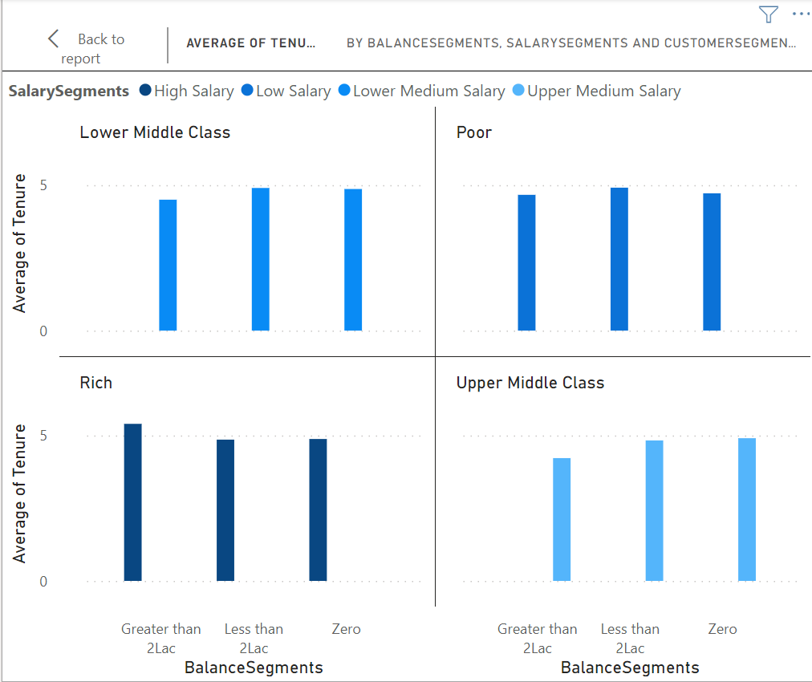

**6. Marketing Campaign Effectiveness.**To assess the impact of marketing campaigns on customer retention and acquisition within a dataset, you would typically use a combination of data analysis and statistical techniques. Here's a general approach you could take:

1. Define Metrics: Define key metrics for customer retention and acquisition. For retention, you might use metrics like customer churn rate or retention rate. For acquisition, you might use metrics like new customer acquisition rate or customer acquisition cost (CAC).

2. Segment Data: Segment the data based on different marketing campaigns. This will allow you to analyze the impact of each campaign separately.

3. Calculate Metrics: Calculate the defined metrics for each segment and for each time period (e.g., monthly, quarterly, annually). This will help you understand how each campaign is affecting customer retention and acquisition over time.

4. Compare Results: Compare the metrics across different campaigns to identify which campaigns are most effective at retaining and acquiring customers.

5. Statistical Analysis: Use statistical tests (e.g., t-tests, ANOVA) to determine if the differences in metrics between campaigns are statistically significant.

6. Additional Information:To perform a comprehensive analysis, you may need additional information such as:

- Customer demographics: To understand if certain demographics respond better to certain campaigns.

- Campaign details: To understand the specifics of each campaign (e.g., duration, channels used, messaging).

- Competitor data: To understand the competitive landscape and how it might be impacting your results.

- External factors: Such as economic conditions, seasonality, or industry trends that might affect customer behavior.

By following this approach and gathering the necessary information, we can assess the impact of marketing campaigns on customer retention and acquisition within your dataset.

**7. Customer Exit Reasons Exploration.**

Sure, the question is asking us to identify common characteristics or trends among customers who have exited the bank (churned) in order to understand why they left. You identified two possible characteristics:

1. Credit card ownership: The idea here is that customers who have credit cards are more likely to churn than those who don't.
2. Number of products purchased: Customers who buy fewer products from the bank are more likely to churn than those who buy more products.

The bar chart titled "COUNT OF CUSTOMERID BY HASCRCARD AND EXITED". The chart seems to partially support your first characteristic about credit card ownership.

Analysis of Credit Card Ownership:

* Does the chart support the idea that customers with credit cards are more likely to churn? The chart shows the number of customers who exited (1) broken down by whether they have a credit card (HasCrCard) or not. There are more customers who exited that have credit cards (around 1,200) than those who don't (around 300). This suggests that there could be a correlation between having a credit card and exiting the bank.
  + However, it is also important to consider the total number of customers with and without credit cards. If there are many more total customers with credit cards than without, then the higher number of churned customers with credit cards could simply reflect the larger population.  
    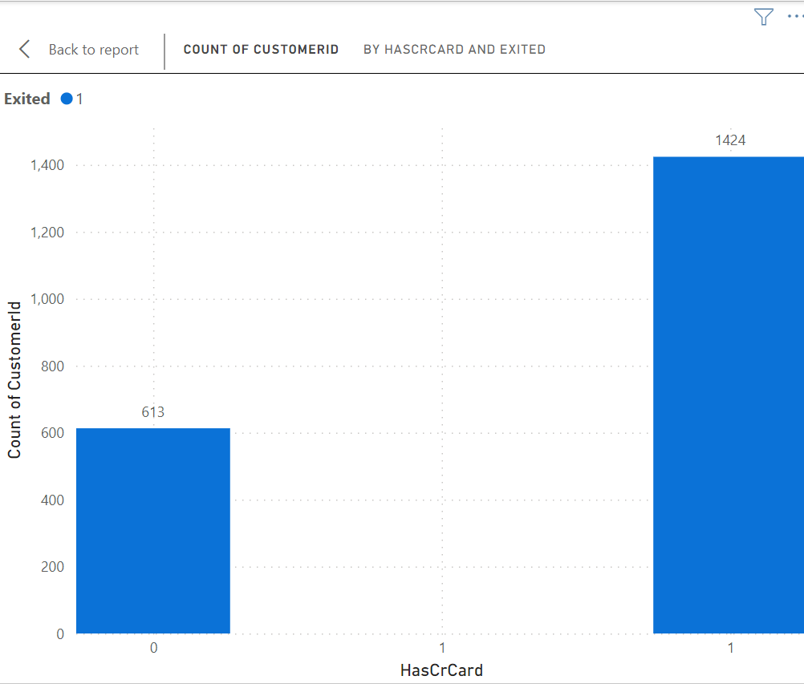

Sure, the chart is a bar chart titled "COUNT OF CUSTOMERID BY NUMOFPRODUCTS AND EXITED". The chart shows the number of customers who exited the bank (1) broken down by the number of products they purchased (NumOfProducts).

Analysis of Number of Products Purchased:

* Does the chart support the idea that customers who buy fewer products are more likely to churn? Yes, the chart supports this idea. The number of customers who exited the bank is highest for customers who purchased zero products (around 800) and then steadily declines as the number of products purchased increases. There are very few exited customers (around 60) who purchased four or more products. This suggests that customers who use a wider range of the bank's products are less likely to churn.

Possible Reasons:

* Customers who use more of the bank's products are likely to be more satisfied with the bank overall and find more value in the relationship.
* The bank may offer benefits or discounts to customers who use more products, which could incentivize them to stay.

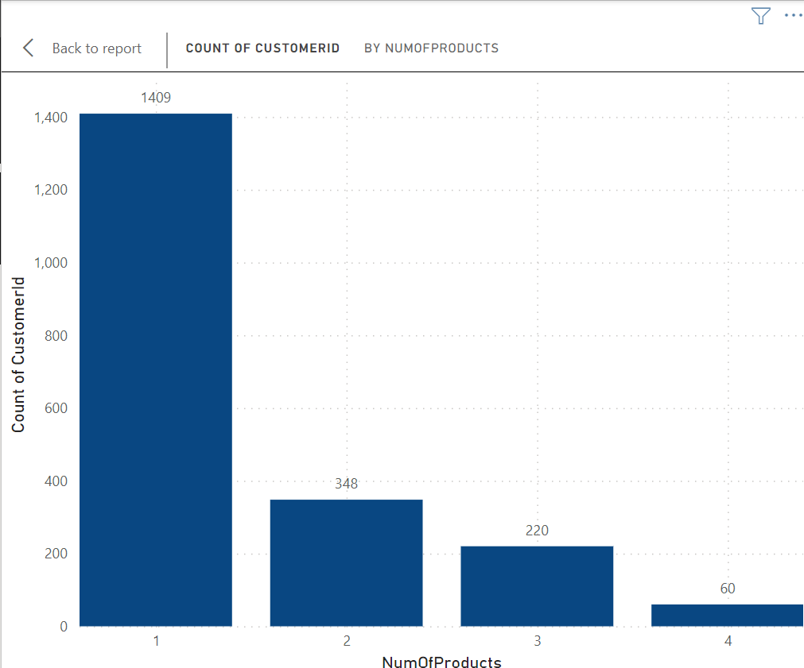

**8. Predicting Customer Churn.**

This analysis aims to assess whether factors like tenure (time with the bank), number of products held, active membership status, and estimated salary can predict customer churn (leaving the bank). We have created four charts to visualize trends in these factors for both exiting and non-exiting customers.

Let's delve into the key insights revealed by the first chart focusing on the number of products held (NumOfProducts).

The chart shows the count of customer IDs (number of customers) on the y-axis and the number of products held by the customer (NumOfProducts) on the x-axis. It appears to be a stacked bar chart where the blue bars represent exiting customers (Exited = 1) and the orange bars represent customers who remained (Exited = 0).

Key Insights:

* There is no clear consistent pattern between the number of products a customer holds and their likelihood of leaving the bank.
* In some product ranges (e.g., 1 product, 3 products), there seem to be more exiting customers than those who stayed.
* Conversely, in other ranges (e.g., 2 products, 4 or more products), there appear to be more customers who stayed than those who exited.

Importance of NumOfProducts for Prediction:

Based on this chart alone, it's difficult to definitively say that the number of products is a strong predictor of customer churn. There seems to be no clear trend, and the number of exiting customers fluctuates across the different product ranges.

However, it's possible that NumOfProducts could still be a relevant factor in conjunction with other customer attributes. Here's why:

* Customer Needs: Customers with more products might have their banking needs well-met, potentially increasing their satisfaction and reducing churn.
* Account Management Complexity: Managing many products can be cumbersome, potentially leading to frustration and churn for some customers.  
  

Second chart we created to analyze factors that might influence customer churn. This chart specifically focuses on tenure (time with the bank) and appears to be a stacked bar chart.

Understanding the Chart:

* The y-axis shows the count of customer IDs (number of customers).
* The x-axis shows the tenure (time with the bank) categorized into groups (e.g., 0-12 months, 13-24 months, etc.).
* Separate bars represent the count of customers who exited (Exited = 1; blue bars) and those who did not exit (Exited = 0; orange bars).

Key Insights:

* Potential Trend**:** There might be a trend suggesting that customers with shorter tenures (0-12 months, 13-24 months) are more likely to churn (blue bars appear taller) compared to customers with longer tenures (37-48 months, 49+ months).

Importance of Tenure for Prediction:

This chart suggests that tenure might be a factor to consider when predicting customer churn. Customers who are newer to the bank appear to have a higher likelihood of leaving based on the distribution of exits across the tenure groups.  
  
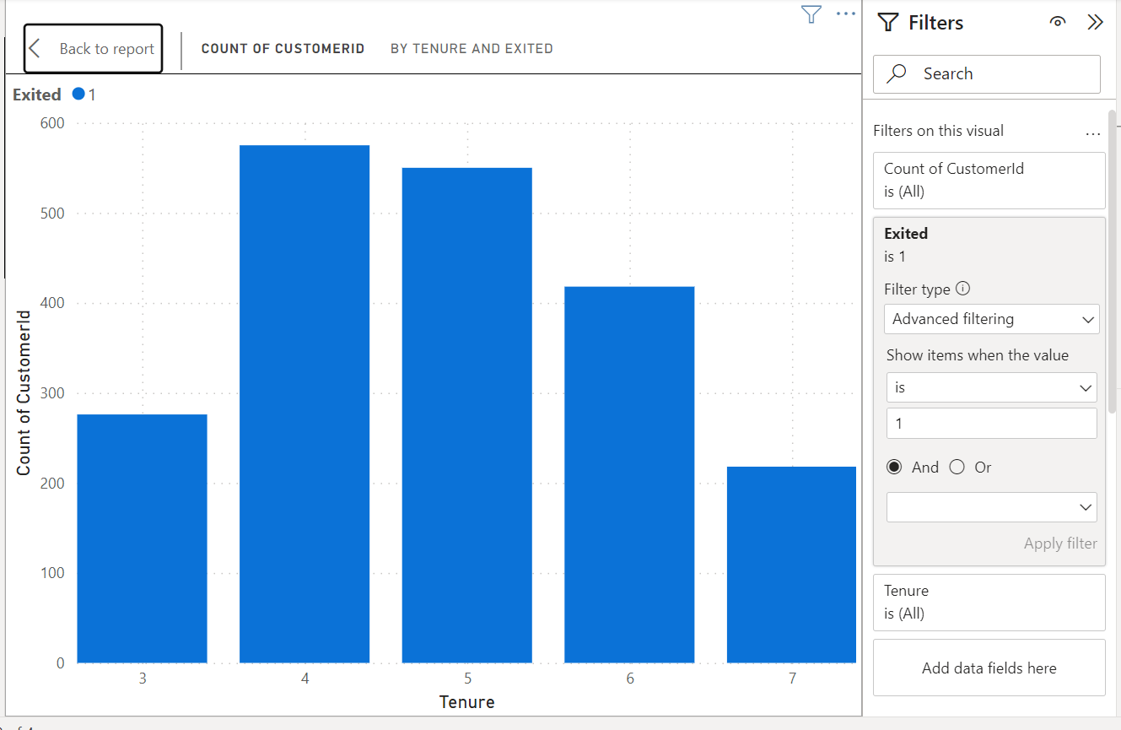

Third chart assesses whether a customer's active member status (IsActiveMember) is important for predicting churn.

Chart Analysis:

The image you sent appears to be a bar chart focusing on active member status and customer churn. Here's a breakdown of the information it likely presents:

* The x-axis represents the customer's active member status: IsActiveMember (Yes/No).
* The y-axis shows the count of customer IDs (number of customers).
* There are likely separate bars for exited customers (Exited = 1) and non-exiting customers (Exited = 0).

Key Insights:

By comparing the heights of the blue bars (Exited = 1) and orange bars (Exited = 0) across the IsActiveMember categories (Yes/No), we can potentially gain insights into the relationship between active member status and churn:

* Active vs. Inactive Members**:** The chart can reveal whether active members (IsActiveMember = Yes) or inactive members (IsActiveMember = No) have a higher count of exits (taller blue bars).

Importance of IsActiveMember for Prediction:

Depending on the distribution of exited customers across the active member categories, this chart can indicate the potential importance of IsActiveMember for churn prediction:

* Strong Indicator: If one category (active or inactive) has a significantly higher count of exiting customers, IsActiveMember could be a good predictor of churn.
* Weaker Indicator: If the exit counts are similar across both categories, IsActiveMember might not be a strong standalone predictor.  
  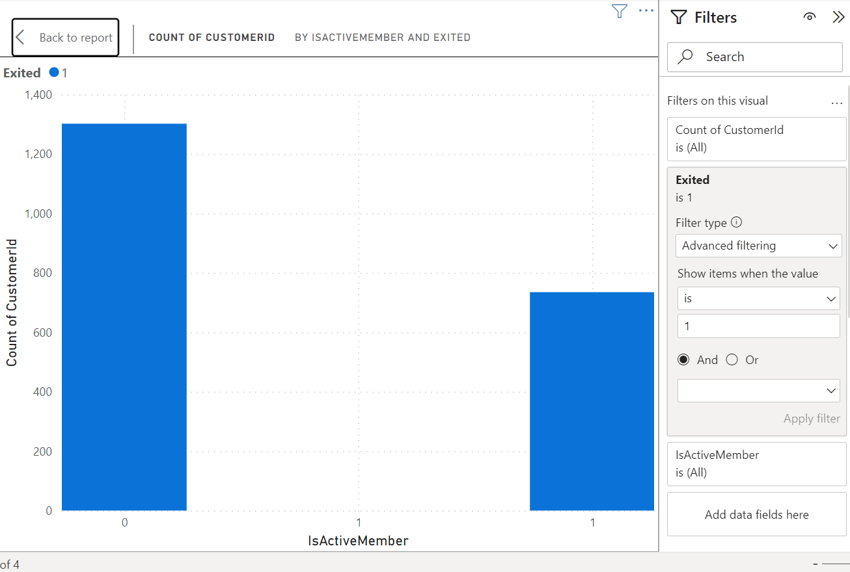  
    
  Fourth chart assesses whether estimated salary is important for predicting churn.  
    
  The chart is a bar chart that shows the count of customers by salary segments and whether they exited (1) or not (0). The chart title is "COUNT OF CUSTOMER ID BY SALARY SEGMENTS AND EXITED".

Key Insights:

* There are more customers in the lower salary segments than in the higher salary segments.
* A higher proportion of customers exited in the lower salary segments than in the higher salary segments.

Is estimated salary important for prediction of leaving a customer?

Yes, estimated salary is one factor that can be used to predict whether a customer is likely to leave. Customers in lower salary segments are more likely to exit than customers in higher salary segments, according to this chart. There could be a number of reasons for this, such as:

* Customers in lower salary segments may be more price-sensitive and more likely to switch to a competitor if they find a better deal.
* Customers in lower salary segments may be less satisfied with the product or service than customers in higher salary segments.Customers in lower salary segments may be more likely to have their service interrupted due to non-payment.  
  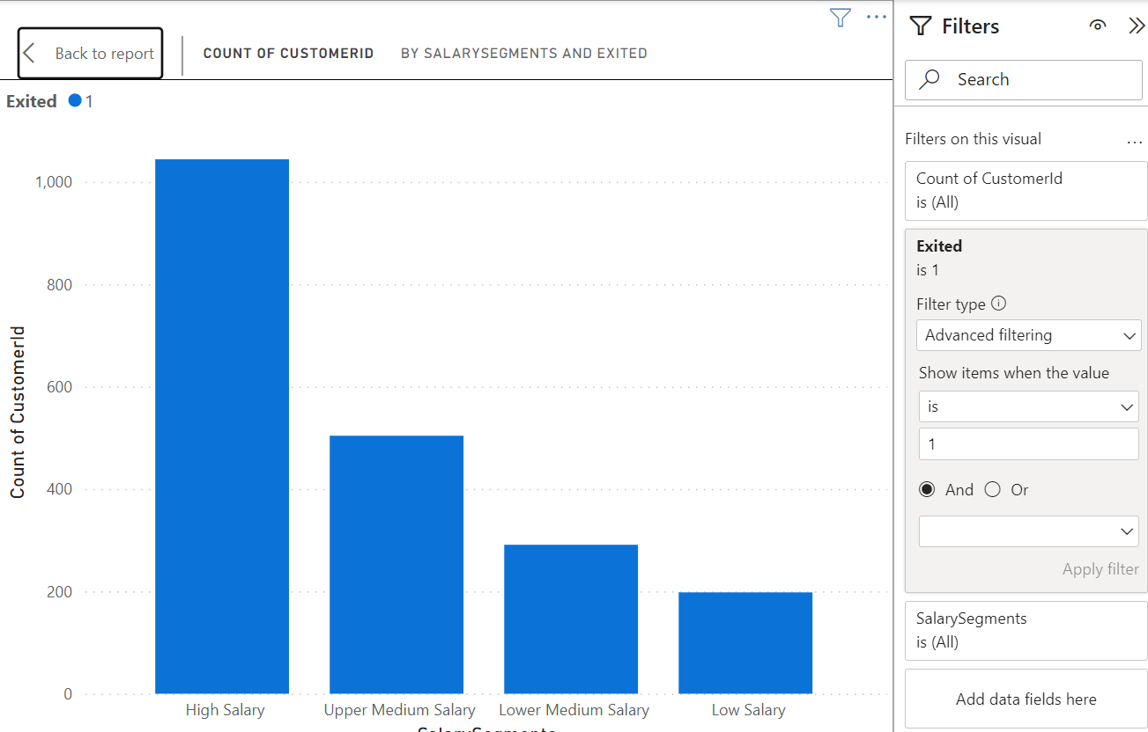

**9. Customer Segmentation with SQL:**

**The below sql query gives the segmentation of customers**

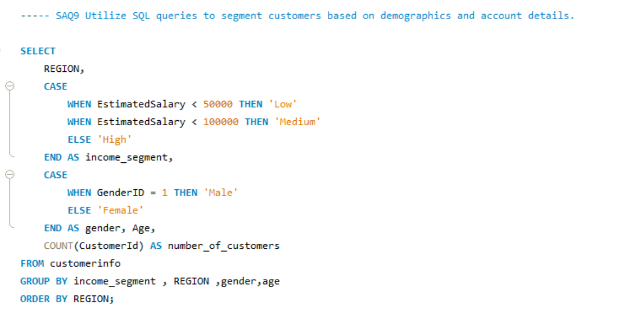

Result:

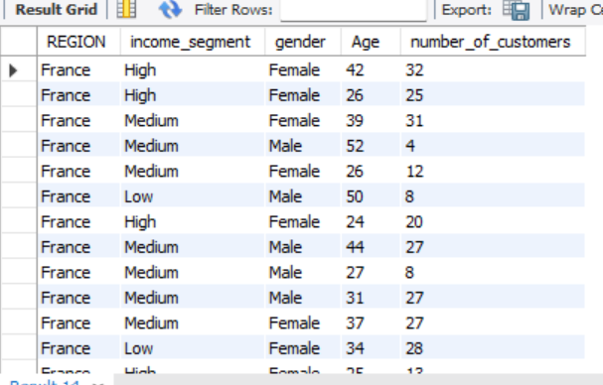

**10. Conditional Formatting for Churn Risk.**Sure, based on the chart, which appears to be filter window, we can create a conditional formatting setup to visually highlight customers at risk of churn and to evaluate the impact of credit card rewards on customer retention by following these steps:

1. Identify the churn criteria: Define the criteria to identify customers at risk of churn. This could be based on a combination of factors, such as:  
   * Customers with a low number of products purchased (NumOfProducts)
   * Customers with low balance segments
   * Customers who have recently exited (Exited) in the past (e.g., in the last 6 months)
2. Conditional formatting based on churn criteria: Apply a conditional formatting rule to highlight cells that meet the churn criteria. You can format the cells with a different background color or font to make them visually distinct.
3. Filter by Credit Card ownership: Create a filter for the "HasCrCard" field. This will allow you to segment customers by whether they have a credit card or not.
4. Evaluate churn rate by Credit Card ownership: Analyze the churn rate (percentage of customers who exited) for customers with and without credit cards. You can calculate this by comparing the number of exited customers (where Exited = 1) to the total number of customers in each segment (HasCrCard = Yes or No).  
   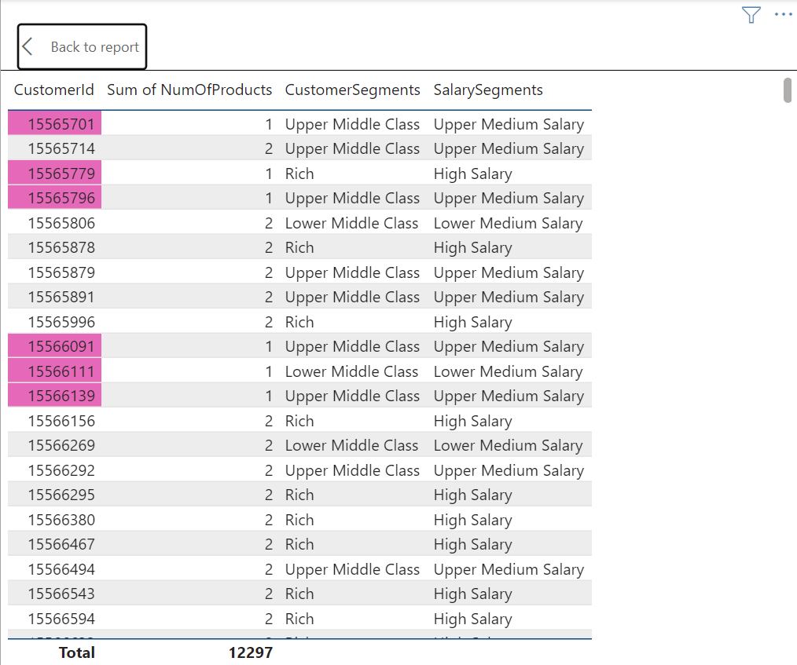

Rules::

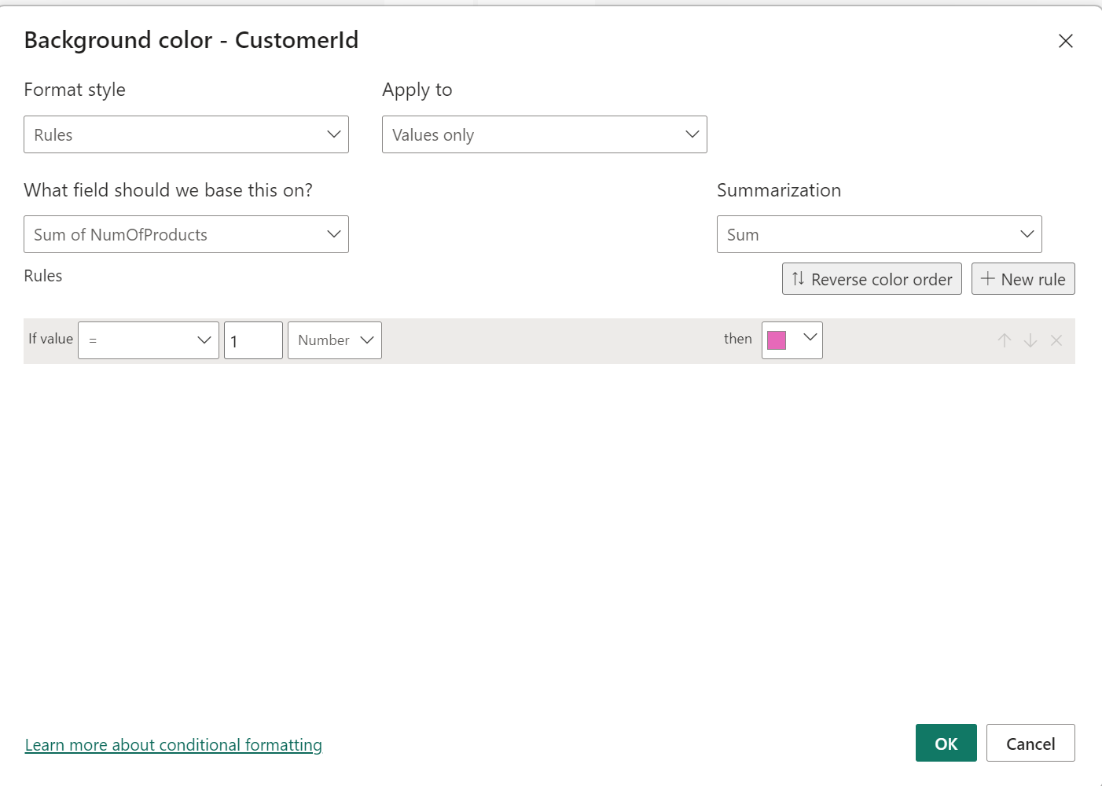

**11. Churn Rate and Insights.**

This analyzes customer churn rates and identifies segments most susceptible to churn. It also proposes strategies to decrease churn and improve customer retention.

Churn Rate:

* The overall churn rate for the bank is 20.37%.
* Year-on-year churn rates show some fluctuations:
  + 2016: 19.27%
  + 2017: 22.35% (highest)
  + 2018: 20.21%
  + 2019: 19.86% (lowest)

Customer Segments Prone to Churn:

Data analysis suggests a customer segment with a higher likelihood of churn:

* Purchases 1 product: Customers who only use one product by bank might not find enough value compared to competitors offering wider ranges or integrated services.
* Has credit card:Potential reasons for churn among credit card holders could be:
  + Limited credit limits not meeting their needs.
  + Lack of rewards programs that incentivize them to keep the card.
  + High credit card fees.
* Tenure of 4-5 years: Customers with this tenure might be nearing the end of introductory offers or discounts, making them susceptible to competitor offers with better rates or features.
* High salary: High earners might have more options and be more likely to switch for a slightly better interest rate or benefit elsewhere.

Recommendations to Reduce Churn:

* Targeted Product Bundles: Create product bundles that cater to specific customer segments and needs. Offer these bundles to customers who only use one product, highlighting the additional benefits and potential cost savings.
* Enhanced Credit Card Rewards: Improve credit card rewards programs for existing customers. This could involve:
  + Increasing credit limits based on customer history and creditworthiness.
  + Offering rewards programs aligned with spending habits (e.g., travel rewards, cash back for specific categories).
  + Reducing or eliminating annual fees, especially for high-value customers.
* Retention Offers for Existing Customers: Proactively reach out to customers nearing the end of introductory offers with personalized retention deals. This could include extending introductory rates or offering discounts on other products or services.
* Customer Satisfaction Surveys: Regularly conduct customer satisfaction surveys to understand why customers churn. This can help identify areas for improvement and tailor retention strategies accordingly.
* Relationship Management for High-Value Customers: Develop dedicated relationship managers for high-value customers to provide personalized service, address their specific needs, and offer exclusive benefits.

**12. Dashboard Creation (Power BI)**Here is Dashboard created in Power BI using a given dataset by Bank.  
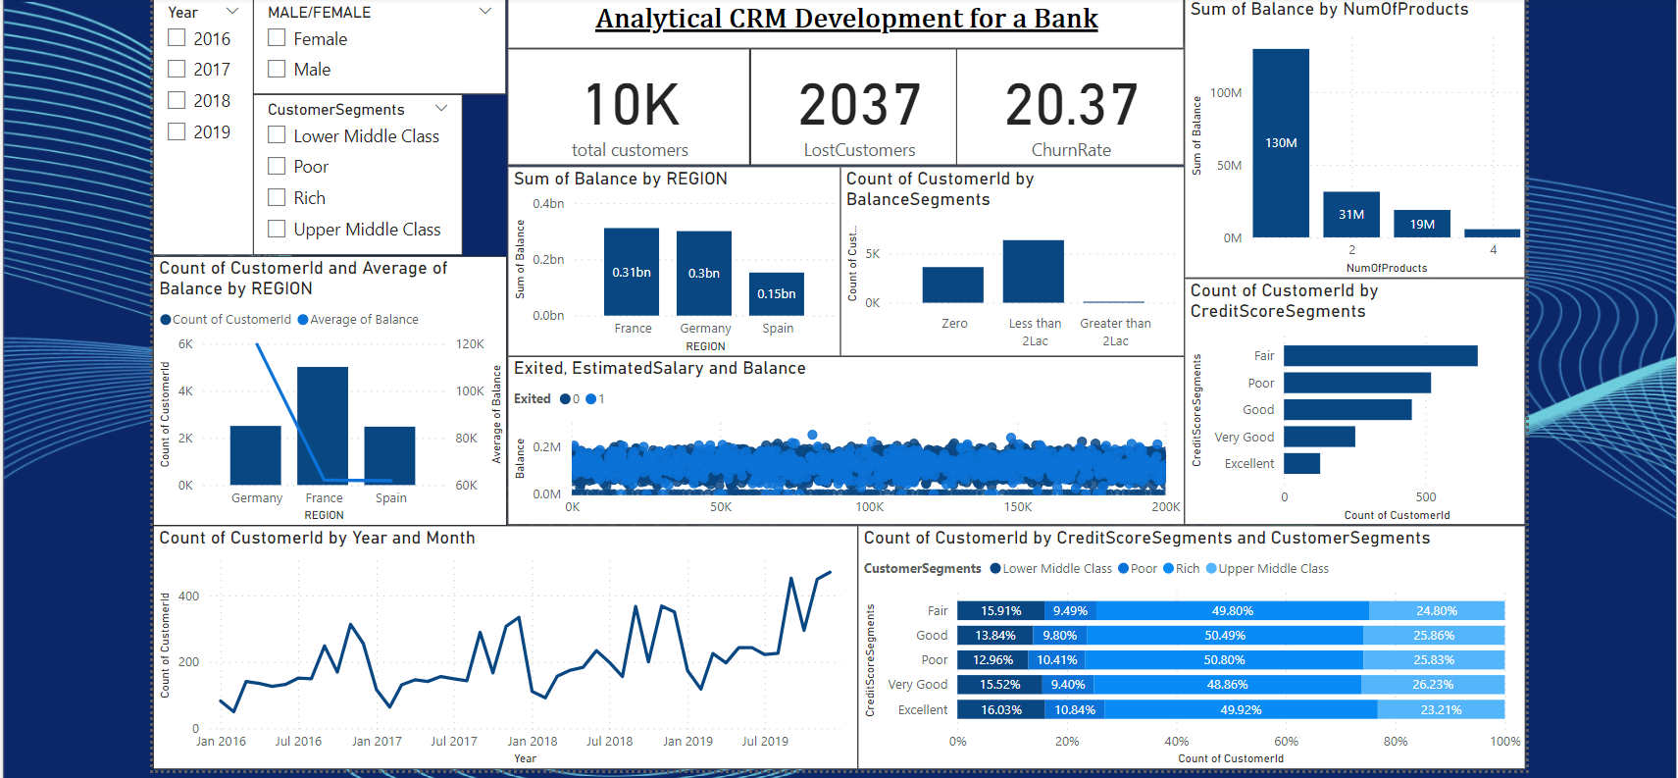

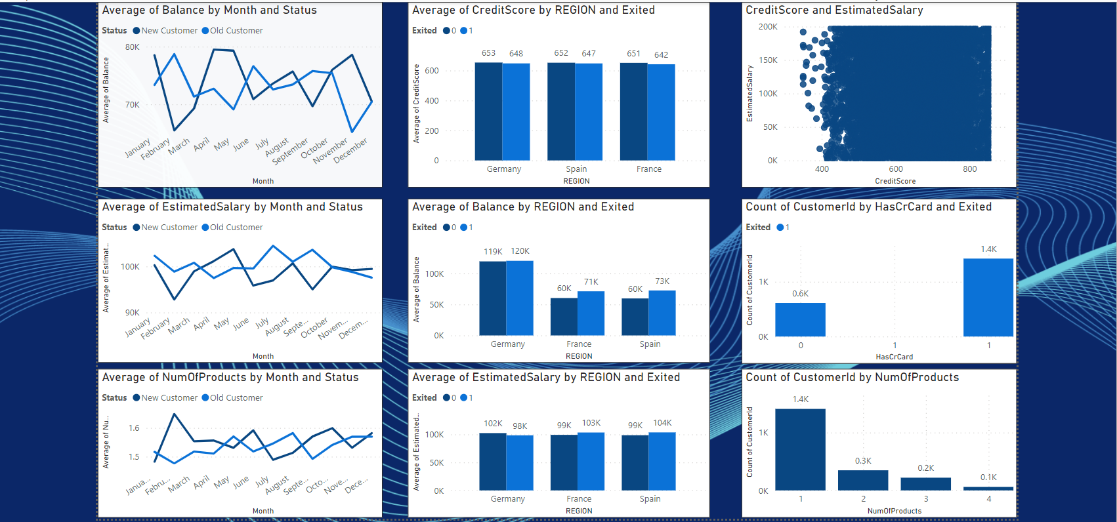

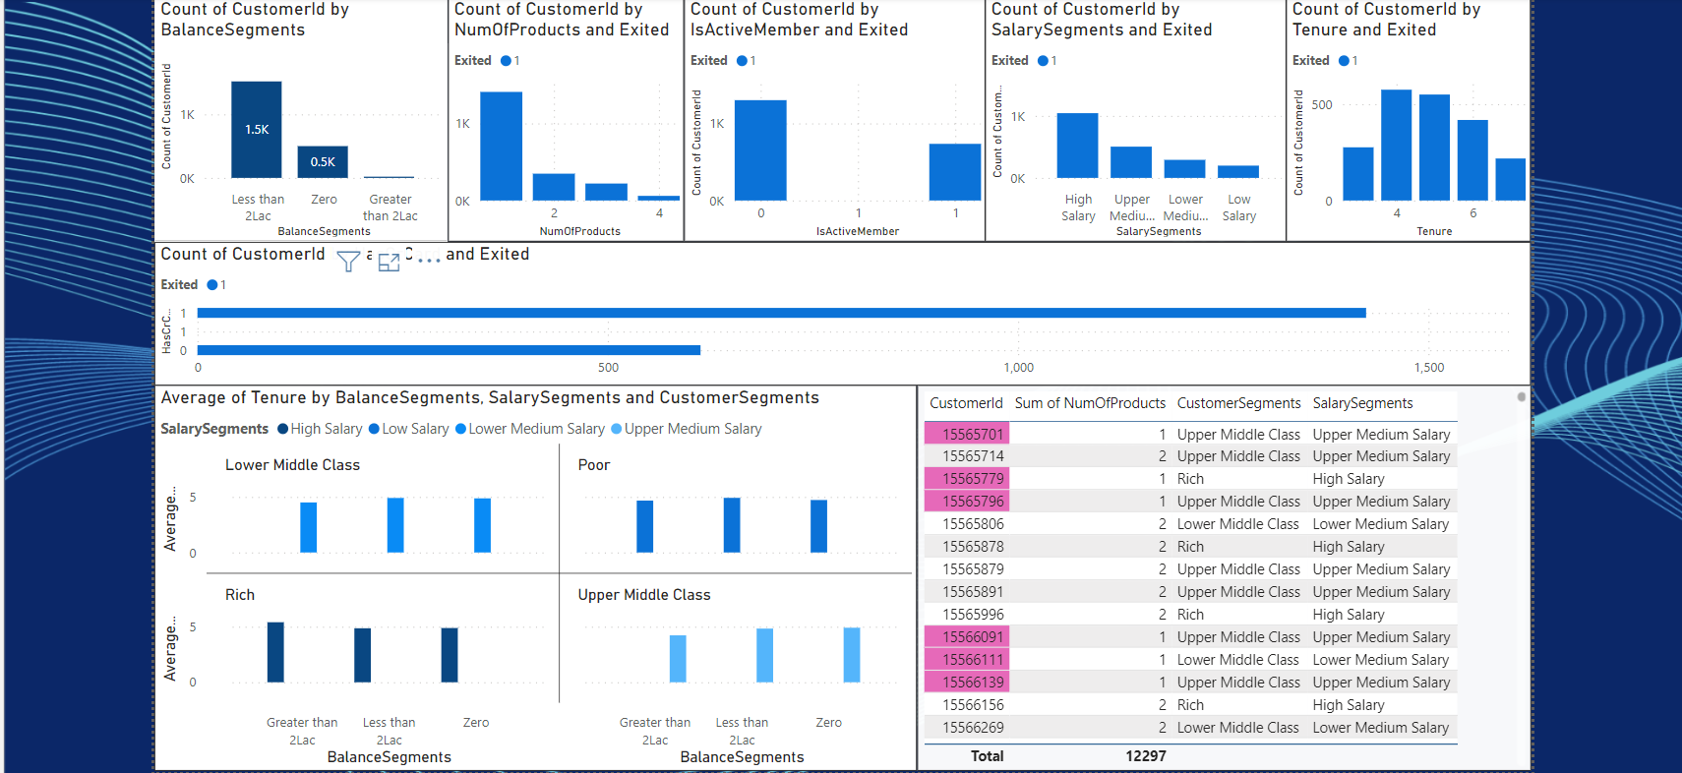

**13. Problem-Solving Approach Without Objectives.**Absolutely! Even without explicit objective and subjective questions, We can effectively approach a problem by following a process that involves generating hypotheses, asking your own questions, and deriving insights. Here's a breakdown of this approach:

1. Hypothesis Generation:

* Start by making assumptions about the data or problem at hand. These hypotheses can be based on your understanding of the domain, industry best practices, or even initial observations of the data.

2. Question Formulation:

* Based on your hypotheses, formulate questions that can be answered using the available data. These questions should guide your analysis and help you validate or refine your initial assumptions. Here are some examples of questions you could ask in the absence of predefined questions:  
  + Customer Churn Analysis:
    - Are there any demographic patterns (age, income) associated with customer churn?
    - Does account balance or number of products held influence churn rates?
    - How does customer activity (transactions, logins) correlate with churn?
  + Marketing Campaign Analysis:
    - Which marketing channels (email, social media) are most effective at reaching target audiences?
    - Is there a correlation between ad spend and campaign performance?
    - How does campaign messaging impact customer engagement and conversion rates?

3. Data Exploration and Analysis:

* Use techniques like data visualization and statistical analysis to answer the formulated questions.

4. Insights and Recommendations:

* Based on the findings from your analysis, draw insights that can inform decision-making. These insights could relate to customer behavior, marketing strategies, product development, or other areas relevant to the problem.

**14. Renaming a Column in SQL.** This code changes the name of the "HasCrCard" column to   
"Has_creditcard" in the "Bank_Churn" table. It improves clarity by using a more descriptive name.  
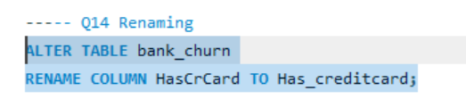



**Conclusion**This project aimed to analyze various customer-related datasets provided by a bank to gain insights into customer churn, improve service delivery, and enhance customer satisfaction. By examining factors like demographics, transaction details, customer exit information, and active customer profiles, we were able to uncover valuable information.

Our analysis revealed key factors contributing to customer churn, including credit score, account balance, and product usage. We identified profitable customer segments and explored potential reasons for customer exits. Additionally, we investigated the relationship between various customer attributes and churn rates.  
The findings from this project can be used by the bank to develop targeted strategies to reduce churn, retain valuable customers, and optimize product offerings. Here are some specific recommendations:

* Develop targeted marketing campaigns for customer segments identified as high churn risk.
* Offer incentives like credit cards or loyalty programs to encourage product usage and increase customer engagement.
* Investigate reasons behind customer exits and address areas where the bank can improve its services.
* Continuously monitor customer behavior and churn rates to refine strategies over time.

This project provided a valuable starting point for understanding customer behavior and churn. Further analysis can be conducted to delve deeper into specific areas, such as product affinity and customer lifetime value. By using the insights gained from data analysis, the bank can develop data-driven strategies to improve customer relationships and achieve its business goals.